What 100+ Language Models Actually Do With Revenue Operations Work
An independent benchmark of 102 frontier and open-source LLMs on 40 real go-to-market operations tasks — deterministic scoring, full cost and latency telemetry, and every answer inspectable.
BonuslyBench Research · Amani Phipps, GTM/RevOps · September 2026
DRAFT — pending additional work. Figures and findings reflect run 2026-09-05; the written analysis is still being revised and should not be circulated as final.

The So What
This exercise set out to answer a deceptively simple question: when you point commercial and open language models at the actual daily work of revenue operations — reconciling an ARR rollforward, auditing CRM stage hygiene, building a weighted forecast, spotting conflicting renewal dates — what actually happens? Not on vendor benchmarks, but on real, messy GTM data from a real company. The short version:
- Open-weight models sat at the top of the table. The strongest overall performances came from open models — Muse-Spark 1.1 (0.977), Kimi K3, MiMo v2.5 Pro, GLM 5.3 Flash, Tencent Hy3 — at total suite costs under $8 each. The best-scoring frontier model (Claude Opus 5, 0.967) tied with an open model that cost roughly 48x less.
- Price stopped predicting quality on this workload. Across 96 fully-tested models, spend ranged up to $131.87 for the same 40 tasks. The most expensive model tested (gpt-5.4-pro) scored below 17 models that each cost under $2. Accuracy on operational work is now nearly free at the top of the market; what premium tiers still sell is speed, polish, and accountability — not measurable correctness on these tasks.
- The hardest work is the judgment, not the arithmetic. Clean single-table math was close to universal. The spread opened on tasks that mix arithmetic with interpretation: which deals to exclude from a quarter, what "stale" means, when to say "the data cannot answer this." No model in the pool solved those perfectly, and the best got 36 of 40.
- Fabrication was rare, patterned, and mechanically catchable. 20 of 103 models invented at least one entity (a deal or company alias that does not exist in the source data) across ~4,500 graded answers. Every instance was caught by a deterministic alias whitelist. The failure mode is real but guardrail-able.
- The benchmark itself needed auditing. Five scoring defects found mid-exercise had made six tests "impossible" — every model failed them, and the failure was the grader's, not the models'. The lesson generalizes: any LLM evaluation should check whether universal failures are the model's problem or the test's, before drawing conclusions.

Why This Benchmark Exists
Public model leaderboards test abstracted skills — competition math, coding, multiple-choice knowledge. None of them measure the texture of operations work: extracts with unpopulated columns, look-alike joins, tracking bugs, dates that disagree across systems, single-account noise dressed as a trend. Meanwhile every GTM organization is being asked to believe that pointing an LLM at a CRM will produce reliable analysis.
BonuslyBench closes that gap for one real GTM stack. It was built from a snapshot of a working revenue organization (September 2026, redacted: company names aliased, no personal data), and its tests are drawn from the work a RevOps analyst actually does weekly — not from a benchmark committee's imagination of that work.

How It Works — The Logic of the Benchmark

The tests
Forty tasks across eight categories of GTM work: CRM and data hygiene, deal intelligence, rep performance, reporting and analytics, customer success, marketing, communication, and ops maintenance. Each test hands the model real CSV extracts and asks for the same deliverable an operator would produce: a forecast with exclusions, an audit with per-owner breakdowns, a renewal risk call with the conflicting dates named.

The traps
Every test embeds the traps that make real GTM data hard: owner columns blank on most rows, renewal dates that disagree between systems, why-buys fields empty exactly where the process requires them, Gong call mappings keyed to deal IDs that no longer exist, "LONG(n)" placeholders, look-alike aliases. A correct answer must either navigate the trap or explicitly say what the data cannot support. Silence about a trap is scored as failure.

The grading
No model judged any other model. Expected answers were computed programmatically from the same CSVs the models saw — never hand-written — and answers are graded by deterministic Python: numeric tolerance bands, regex presence checks, alias whitelist matching, format-compliance rules. The same code, same truth, same tolerances for every model. Any grader defect affects all models identically and is auditable in the open scorer code.

The curation
103 models across 30 providers, capped at roughly five per provider family (the GPT line was deliberately given more breadth). Grok models were excluded mid-exercise by decision and removed from all artifacts. The pool spans frontier labs (OpenAI GPT 5.x/6 lines including pro-tier reasoning models, Anthropic Claude Opus line, Google Gemini, Amazon Nova) and open weights (Qwen, GLM, DeepSeek, Kimi, Muse, Tencent Hy, MiMo, MiniMax, LongCat, Solar, and more). Every model ran the same 40 tests; 96 reached full coverage, and the remainder are reported with exact partial counts rather than dropped or silently scored.

The Results in Detail

The top of the table
Mean scores across the suite cluster tightly: the best model answered 35 of 40 tests perfectly (0.977), and twenty models scored above 0.95. No model aced the suite — the ceiling on operational work remains unbroken, which is itself a finding.
Rank | Model | Mean | Perfect | Cost
1 | meta/muse-spark-1.1 | 0.977 | 35/40 | $2.17
2 | moonshotai/kimi-k3 | 0.976 | 36/40 | $7.67
3 | xiaomi/mimo-v2.5-pro | 0.974 | 36/40 | $0.69
4 | meta/muse-spark-1.3 | 0.973 | 35/40 | $3.03
5 | z-ai/glm-5.3-flash | 0.968 | 35/40 | $0.28
6 | tencent/hy3-preview | 0.968 | 34/40 | $0.59
7 | anthropic/claude-opus-5 | 0.967 | 35/40 | $15.91
8 | tencent/hy3 | 0.967 | 36/40 | $0.33
9 | google/gemini-3.8-flash | 0.966 | 34/40 | $6.34
10 | qwen/qwen3.8-flash | 0.965 | 34/40 | $0.34
Top 10 of 96 fully-tested models. Full matrix: 01_Results/BonuslyBench_Final_Results.html.
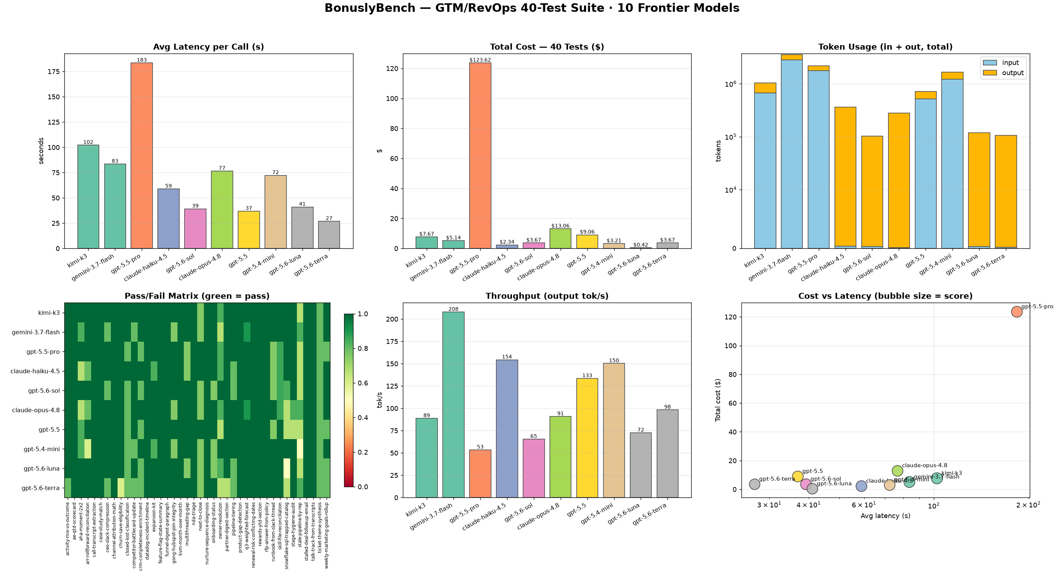
The six-panel dashboard: latency, cost, token usage, pass-fail matrix, throughput, and cost-vs-latency for all fully-tested models.

Where scores separated
Category means were close — most models were within a few points across all eight categories. The discriminating tests were the heavy multi-table ones: the ARR rollforward reconciliation, the stale-pipeline audit, the weighted Q3 forecast, and owner-resolution against a join table. These demand sustained arithmetic across tens of kilobytes of records plus honest handling of missing data. They are the closest proxy in the suite to the judgment a working analyst applies, and they produced the widest spread.
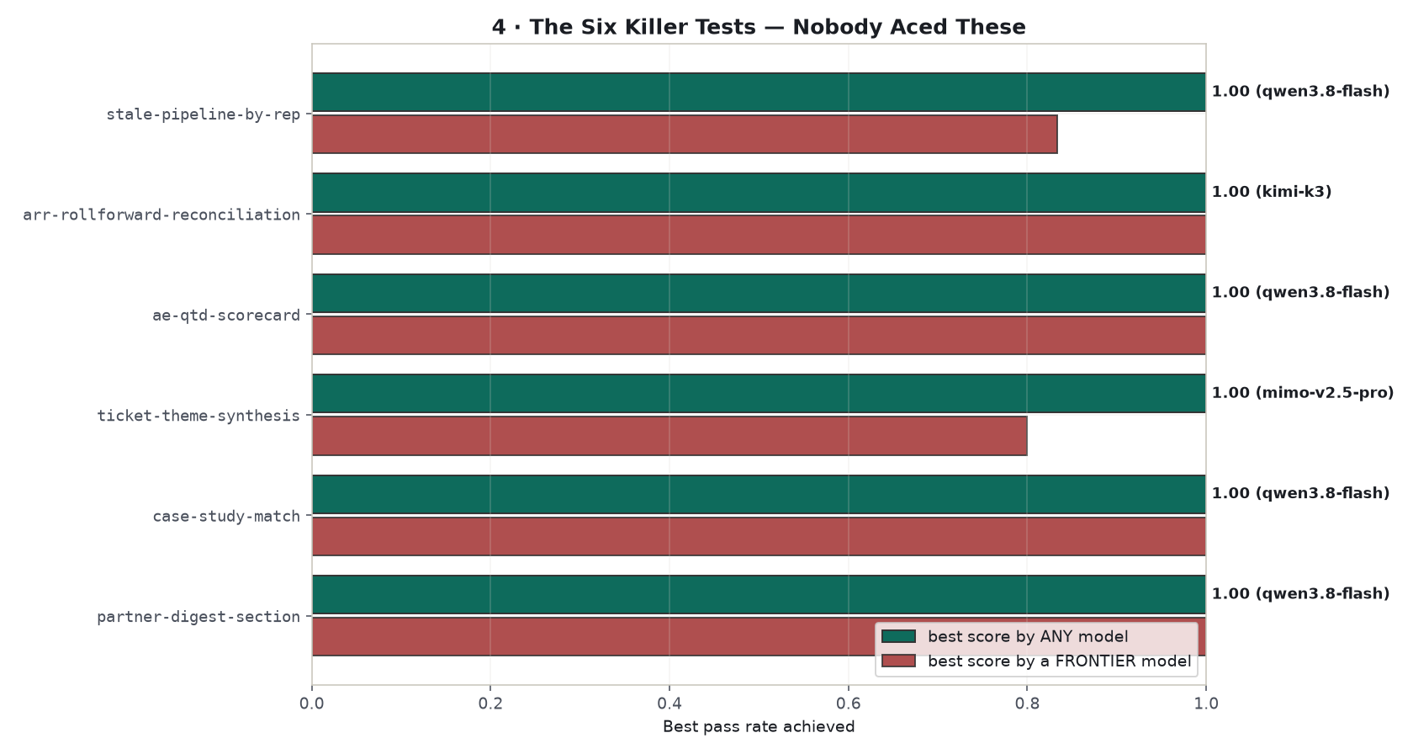
The hardest tests by average pass rate — the multi-table reconciliation and audit tasks where model scores spread widest.

Speed was a real, independent axis
Median response time ranged from under 20 seconds to over 40 minutes per task. Some models traded accuracy for speed (diffusion-decoder and small tuned models); heavyweight reasoning models traded the opposite. For embedded workflows this is a genuine two-axis choice — the pool contains both fast-and-accurate and slow-and-accurate profiles at similar cost.
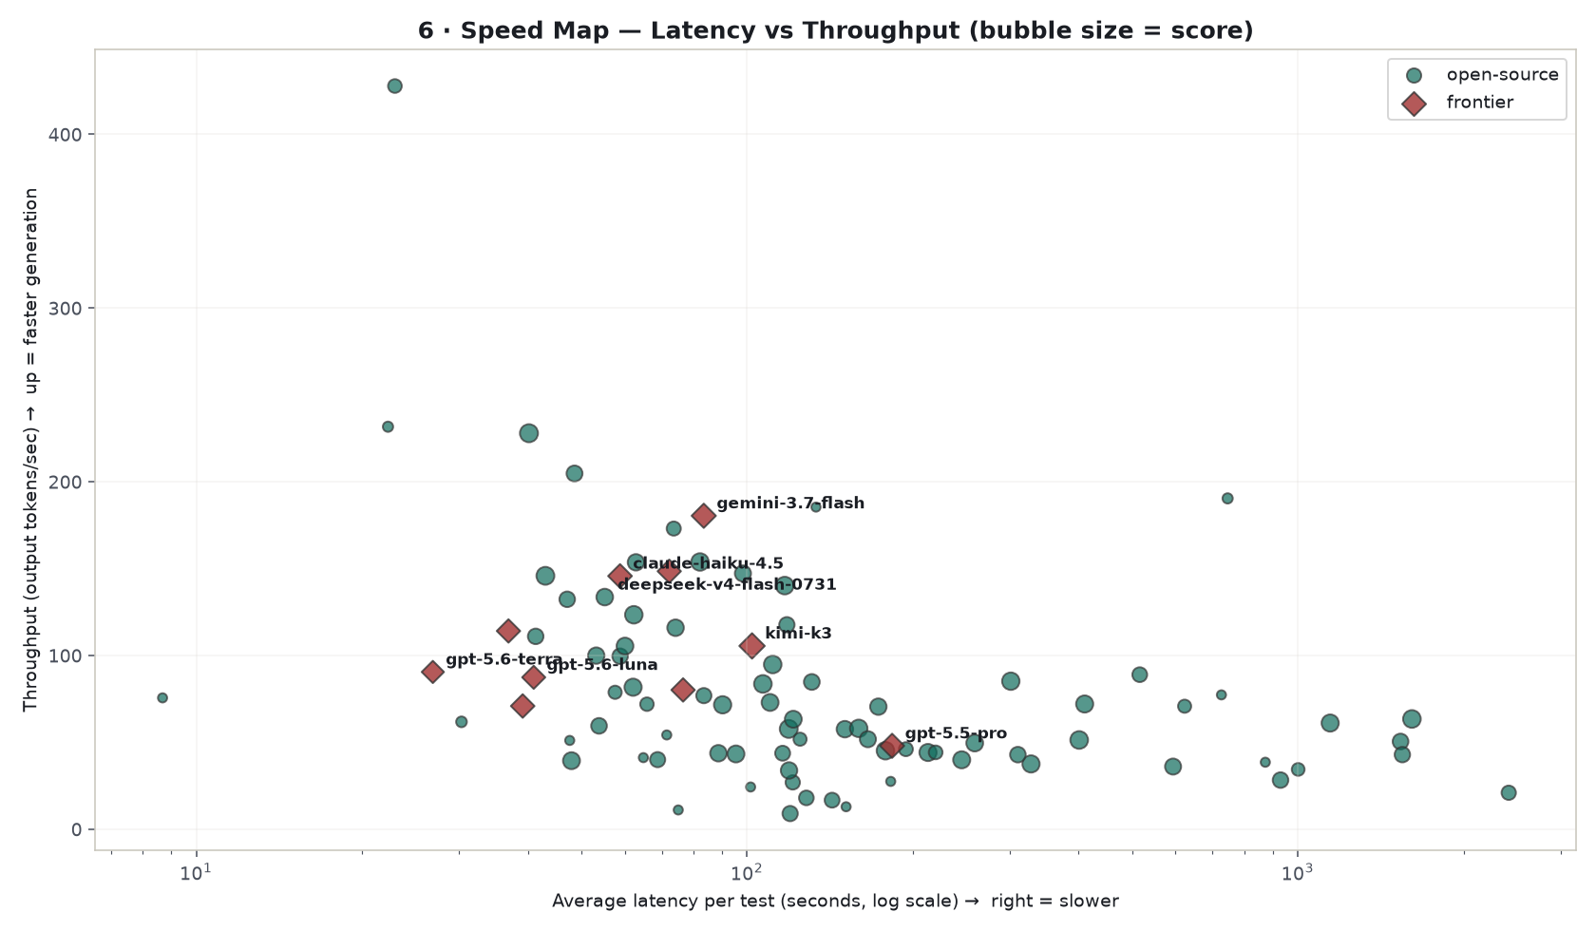
Latency vs accuracy: the speed map. Fast-and-accurate profiles occupy the upper-left; heavy reasoning models sit right.

Behavioral Archetypes — How Models Behaved
Rather than a single ranking, the pool was clustered on behavioral dimensions: per-category strengths, cost, latency, fabrication events, and math-vs-prose tilt. Six profiles emerged. These are observations of how models behaved on this benchmark — an acknowledgement, not a recommendation:
- The Complete Analysts (26 models) — elite accuracy, fast, no weak flank. Behaved like a strong senior analyst: correct math, disciplined format, honest caveats. Included open and frontier models at very different prices.
- The Reliable Operators (33) — budget workhorses. Steady on routine execution and ops maintenance; thinner on the hardest multi-table reconciliation.
- The Capable but Loose (12) — strong scores, but this cluster and the Speed Specialists together carried every fabrication event in the study: at least one invented deal or company alias. Correct on most work; output that warrants entity validation before production use.
- The Fast Communicators (7) — comfortable writing digests and emails; weak on weighted-forecast and rollforward math. Good words, shaky arithmetic.
- The Speed Specialists (8) — ultra-fast (median 18s) with mid-tier accuracy. Where a quick pass matters more than a right one.
- The Non-Functional (5) — endpoints that returned instant garbage or refused the work. Documented as broken routes, not scored as failures.
Full archetype tables with every member model: 05_Models/BonuslyBench_Model_Archetypes.html.
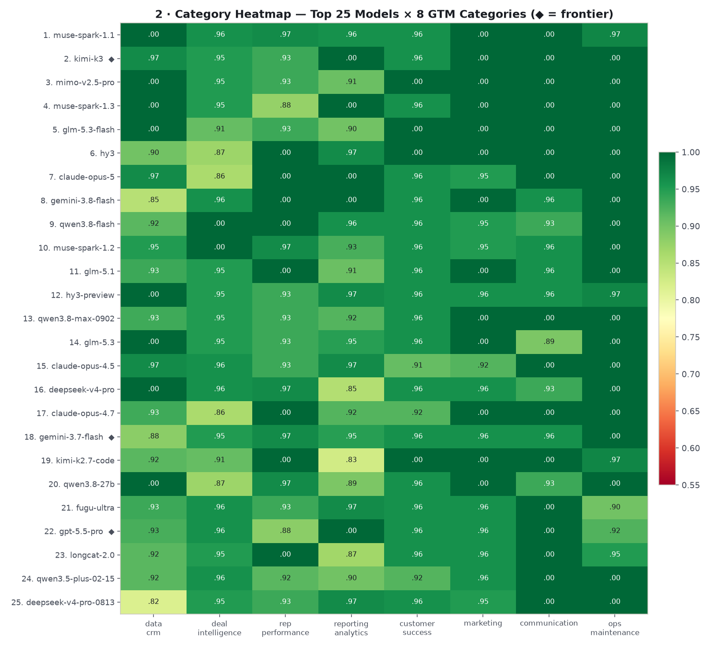
Category heatmap: mean pass rate by model across the eight categories of GTM work.

Cost and Value Observations
Total spend across the exercise was $772.69. Within that, the price of identical work varied by four orders of magnitude: the cheapest complete run cost under a cent, the most expensive cost $131.87). Two objective observations follow. First, a pareto frontier of 6 models at 0.90+ mean defines the cheapest price at every quality level, and it is populated entirely by open weights. Second, the premium tier did not separate itself on accuracy: the most expensive model tested scored below 17 models costing under $2 in total. What premium prices purchased on this bench was latency consistency and output polish — attributes this benchmark measures but does not price.
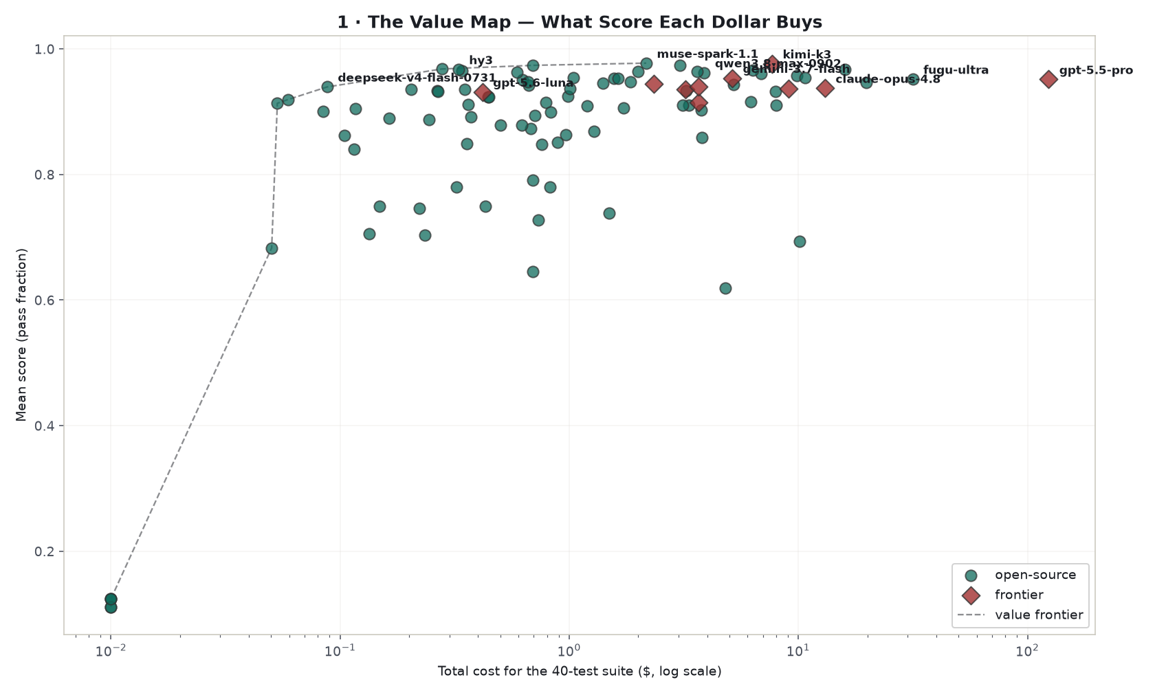
The value map: accuracy vs total suite cost. The pareto frontier (cheapest at every quality level) is populated by open models.

Data Integrity and Fabrication
Every response was screened against an entity whitelist: any deal alias, company alias, or ID that does not exist in the source data is flagged. 20 of 103 models produced at least one fabricated entity across the graded corpus. The rate was concentrated — a small number of small models accounted for most events, while most top performers were clean. The practical finding: in a domain where outputs cite entity IDs, hallucination is detectable with a deterministic guardrail that costs nothing to run. Every flagged instance is visible in the Response Reviewer with the exact fabricated alias named.

The Methodological Finding: Audit the Grader
Mid-exercise, six tests showed zero perfect scores across the entire pool — "impossible" tests. A verification pass read actual model answers against expected truth and found five defects in the scoring code and one truth file with missing fields: negative numbers stripped by the numeric parser, a wrong join key, dictionary-vs-string handling, and one check that validated against the truth file instead of the response. After repair, all 40 tests were ace-able — and one model (Kimi K3) moved from 31 to 36 perfect tests with no re-runs, because its correct answers had been on disk the whole time. Any organization running LLM evaluations should treat universal failure as a grader defect hypothesis first, and read the actual responses before concluding anything about the models.

Scope and Limitations
- One company's GTM stack at one snapshot (2026-09-05), redacted. Scores describe operational skill on this distribution of work, not general model capability.
- Deterministic grading measures operational accuracy and instruction compliance — not prose quality, creativity, or judgment under ambiguity beyond what the tests encode.
- Credential availability limited some families (Claude Sonnet/Fable and several Gemini variants did not route during the run; documented as backlog in the model reference guide).
- A handful of slow endpoints ended with partial coverage — every one is reported with its exact completed-test count, never scored on unrun tests, never dropped.
- Pricing reflects OpenRouter list prices at run time; latency reflects one network path. Neither is a vendor verdict.

The Companion Artifacts
Every claim in this document is inspectable in the package. The folder is designed for independent verification:
- 01_Results/BonuslyBench_Final_Results.html — the full 102x40 results matrix; every cell links to that model's actual answer for that test.
- 01_Results/BonuslyBench_Results.xlsx — the spreadsheet version (Google-Sheets-ready): leaderboard, full matrix, test difficulty, model info with release dates and pricing.
- 03_Answers/reviewer/index.html — the Response Reviewer: for every model and every test, the question asked, the correct answer, and the model's unedited response side-by-side with per-check grading.
- 02_Tests/BonuslyBench_Test_Specification.pdf — all 40 tests with their planted traps, scorer checks, and grading methodology.
- 05_Models/BonuslyBench_Model_Reference_Guide.html — every model with provider, release date, pricing, and positioning.
- 05_Models/BonuslyBench_Model_Archetypes.html — the six behavioral profiles with full member tables and the cost-for-value dollar map.
- 04_Graphs/ — the dashboard and seven analysis charts (also embedded above).
Note: links resolve relative to this document's folder. Open the package root in a browser or file manager and navigate from there.

Closing Observation
The benchmark's own error story is part of the finding. Six "impossible" tests were the grader's bugs, caught only by reading real answers against real truth. The response of this exercise to every headline number — including its own — is the same: open the Response Reviewer, pick a model, and read its work next to the correct answer. The value of an evaluation is not the leaderboard it produces; it is whether a stranger can audit it. That is the standard this package was built to meet.
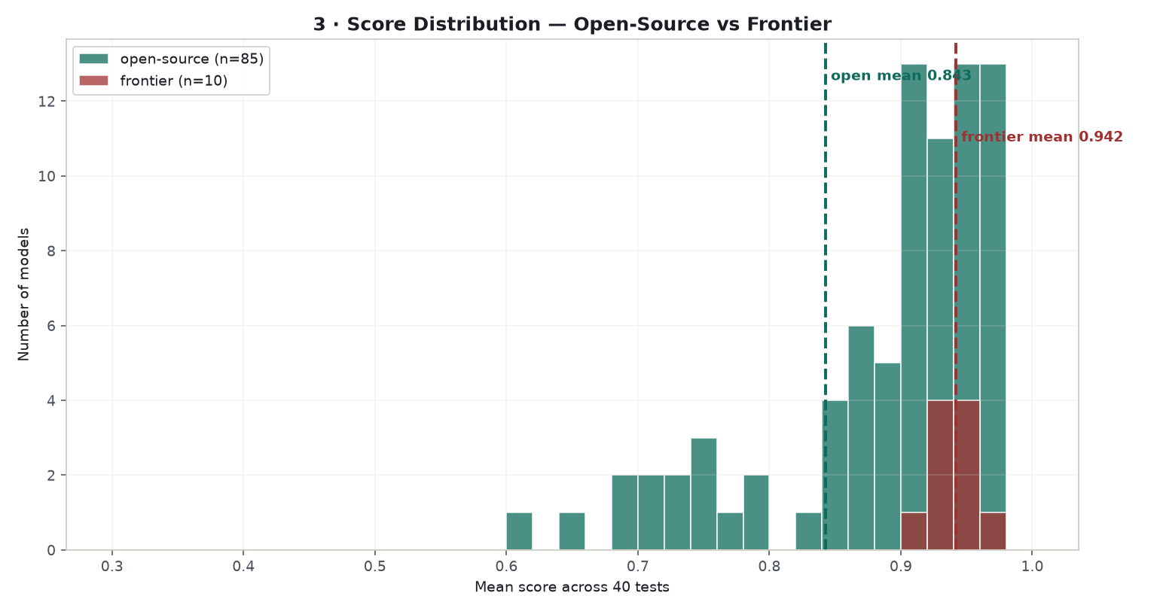
Score distribution across the full pool: tight clustering at the top, a long tail below, and the non-functional cluster at the floor.
— Amani Phipps, September 2026. Benchmark materials, scorers, raw responses, and every artifact referenced above are in the BonuslyBench_Final_Package folder.

